Basavarajeswari group of Institutions

# BALLARI INSTITUTE OF TECHNOLOGY & MANAGEMENT, BALLARI

**“JnanaGangotri" Campus, No.873/2, Ballari-Hospet Road, Allipur, Ballari-583 104 (Karnataka State)**

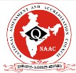

2021-2022

# C++ PROJECT LAB-2021-22

## A Mini-Project Report On

“Hotel Management System ”

## A project work designed and developed as a part of C++ PROJECT LAB for the Academic Year 2021-22.

### PROJECT ASSOCIATES:

**Janardan Kulkarni 3BR20CS068**

### K Shashank 3BR20CS073

**Kshantha Sagar 3BR20CS085**

### Kushal 3BR20CS087

**TABLE OF CONTENTS**

|  |  |
| --- | --- |
| **S.N** | **TOPIC** |
| 1. | **ABSTRACT** |
| 2. | **INTRODUCTION** |
| 3. | **OBJECTIVES** |
| 4. | **EXISTING SYSTEM & PROPOSED SYSTEM** |
| 5. | **SCOPE OF THE PROJECT** |
| 6. | **RESULTS** |
| 7. | **CONCLUSION** |
| 8. | **REFERENCE** |

### ABSTRACT

* The purpose of this project is to replace the existing manual system, by the help of computerized equipments and full-fledged computer software, fulfilling their requirements, so that their valuable data/information can be stored for a longer period with easy accessing and manipulation of the same. The required software and hardware are easily available and easy to work with.
* Hotel Management System, as described above, can lead to error free, secure, reliable and fast management system. It can assist the user to concentrate on their other activities rather to concentrate on the record keeping. Thus it will help organization in better utilization of resources. The organization can maintain computerized records. without redundant entries. That means that one need not be distracted by information that is not relevant, while being able to reach the information.

### INTRODUCTION

* Project title "Hotel Management" (a project for keeping customers record and also calculate customer bill slip )The name of project is "Hotel Management". The objective of the project is to computerize the system of the hotel. "Hotel Management is the project not only keeps the record of various people like customers, manager etc. but as well as it reduce the extensive paper work in the present system. It wills maker the system more versatile and user friendly. It also calculates the proper billing slip of high level and middle level customers. This project is based on description about the structure of HOTEL MANAGEMENT SYSTEM. The project contains:
* Keeping the record of all persons like customers, Employees etc.
* Maintains proper list of all persons.
* Generating proper result on reserved Rooms and Room Tracking

### OBJECTIVES

* The main objective of this c++ project is to ensure reliable and efficient communication within hotel and avoid common input errors done by hotel staff.
* This project also aims and fast and easy retrieval of hotel guest records for faster reference activities.
* Third main important objective of this project is to enforce security measures to avoid unauthorized access to the customer record.

1. **EXISTING & PROPOSED SYSTEM**

Existing System is the manual system used in this market , the proposed system is of the new software based computerized system . This system reduces the errors caused by humans .

### SCOPE & FEATURES OF THE PROJECT

This project offers various services, Hotel management system project maintains record of all the customers. The advance room booking can be done through this . As the customer comes in the hotel the check in entry is done in the software and when customer finally leaves the hotel then check out entry is done through the software and final bill is generated. Some more features of this project are as follows:

1. The whole project is menu driven based and provides very strong security features as it uses various access specifiers .
2. It gives the advantage of computerized system over the manual system.
3. This software is very simple. Hotel employees don’t need any special computer skills to operate this software .
4. Hotel management system project has relatively low running cost as this is a offline software so it doesn’t requires internet services etc.

**7.CONCLUSION**

Hotel management system now-a-day have the advantage of modernization. Computer have done the work more easy. Computer is playing a important role in management. Reports are made on daily basis for every customer check in or check out which can easily be seen by the management . Hotel management system has also primary purpose is to provide facilities to customers. A software for computers makes the things many times easy, these are made as user friendly and to keep an check and balance in hotel management and accounts as well.

Therefore it reduces the human workload and possible errors.

**7.RESULT SCREENSHOTS**

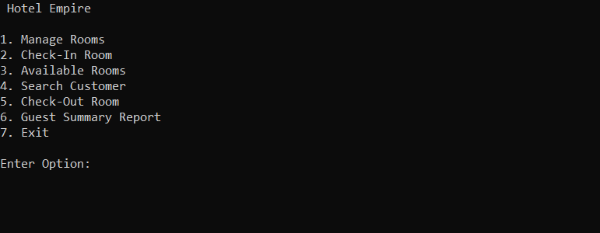

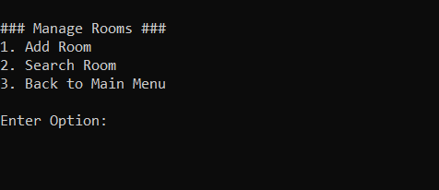

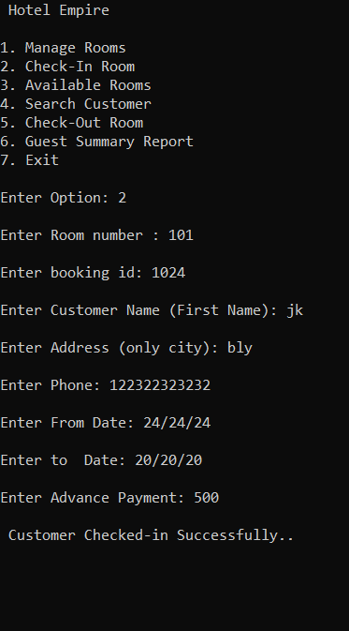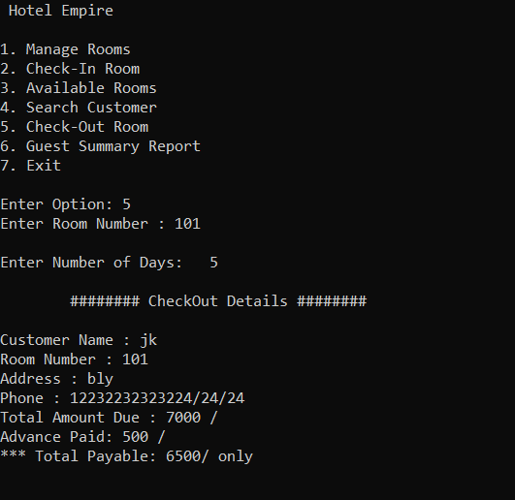

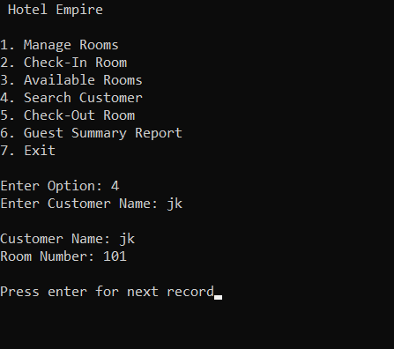

**8.REFERENCES**

1. Object oriented programming by Sourav Sahay.
2. <https://stackoverflow.com/questions>
3. <https://www.geeksforgeeks.org/> (data structure)
4. <https://www.youtube.com>